Genii Data Model

# Overview

This document explains the data model that is available to the data connector. This model is the one that will be used by users of the data connector. The data connector has multiple views available as this system was initially built as a prototype so there are some views that are still available but will not be maintained and if the views cause performance problems they will be removed when required.

There are 3 main databases used in this system to allow for maximum performance with minimal maintenance.

ASPDB – This is a Genii term when referring to the security database.

GeniiDB – This refers to the Genii Systems database, this is where the Genii proprietary data resides.

CustomerDB(s) – This refers to the Customers database, this is the data that the customer technically owns and should have access to.

There are some lookup values that are used to assist and complete processes that reside in the Genii DB these values will not be available through the data connector.

There are usernames and passwords available in the ASPDB the data connector will not have access to this data.

The data connector will allow a customer to connect to their respective database. Note, that this system was built for BPO’s and thus there are multiple databases for multiple customers.

## Models

There are very few key models in this system.

* **v_Campaigns:**

This model stores the campaigns and their specific configurations this is a view of a table that is not available in the customer DB.

* **v_Answers:**

This model stores all the answers for a customer for all their campaigns.

* **v_QAquestionlists:**

This model stores all the questions for a customer for all their campaigns.

* **vqv_BiCaptures:**

This is the model that stores all the assessments that have been completed.

## ERD:

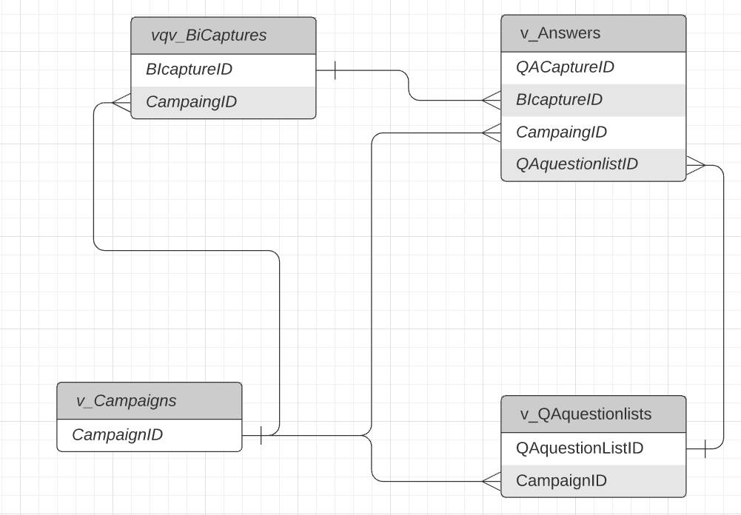

## Definitions:

### v_Campaigns:

[CampaignID] [bigint] IDENTITY(1,1) NOT NULL:

The Unique identifier of a campaign.

[Description] [nvarchar](100) NOT NULL:

The description of the campaign.

[CustomerID] [nvarchar](max) NULL:

The Unique identifier of a customer wo which the campaign belongs.

[DateStart] [datetime] NOT NULL:

The start date of the campaign.

[DateComplete] [datetime] NOT NULL:

The end date of the campaign. This column may be deprecated.

[Status] [nvarchar](20) NULL:

The status of the campaign, eg: Run, New, Closed.

[Remarks] [nvarchar](250) NULL:

Remarks that are associated to the campaign.

[Instructions] [nvarchar](max) NULL:

Instructions that are associated with the campaign.

[EnableReason1] [bit] NOT NULL:

Is reason 1 enabled for the campaign.

[EnableReason2] [bit] NOT NULL:

Is reason 2 enabled for the campaign.

[EnableReason3] [bit] NOT NULL:

Is reason 3 enabled for the campaign.

[EnableCallAgentClass] [bit] NOT NULL:

Is call agent class enabled for the campaign.

[EnableCallReason] [bit] NOT NULL:

Is call reason enabled for the campaign.

[EnableCallDuration] [bit] NOT NULL:

Is the call duration enabled for a campaign.

[EnableNPSresponseID] [bit] NOT NULL:

Is the NPS response ID enabled for a campaign.

[EnableCallFCR] [bit] NOT NULL:

Is the call FCR attribute enabled for a campaign.

[EnableCallRepeat] [bit] NOT NULL:

Is the repeat call option available for a campaign.

[EnableServiceLine] [bit] NOT NULL:

Is the service line enabled on the campaign.

[EnableCustomerAccountNo] [bit] NOT NULL:

Is the customer account number enabled for the campaign.

[EnableSystemRefNo] [bit] NOT NULL:

Is the system ref no enabled for the campaign.

[SettingBIcalibrationCount] [int] NOT NULL:

The value of the BI Calibration count, deprecated.

[EnableBIdataSelectOption] [bit] NOT NULL:

Is the BI data select option available.

[Customer_CustomerID] [bigint] NULL:

FK, used by EF Ignore.

[EnableAgentID] [bit] NOT NULL:

Is the agent ID enabled for the campaign.

[CampaignType] [nvarchar](100) NULL:

The campaign type, this dictates to the system how to report and treat the data.

[CampaignConfig] [nvarchar](100) NULL:

The license configuration of the campaign, this dictates how the questions are restricted.

[SysFolderAudio] [nvarchar](250) NULL:  
 The folder where the audio files are located.

[TargetUserDaily] [nvarchar](250) NULL:

The user daily target for assessments.

[TargetCampaign] [nvarchar](250) NULL:

The campaign target.

[SamplePlanMon] [smallint] NOT NULL:  
 How many assessments to be done on Monday.

[SamplePlanTue] [smallint] NOT NULL:

How many assessments to be done on Tuesday.

[SamplePlanWed] [smallint] NOT NULL:

How many assessments to be done on Wednesday.

[SamplePlanThu] [smallint] NOT NULL:

How many assessments to be done on Thursday.

[SamplePlanFri] [smallint] NOT NULL:

How many assessments to be done on Friday.

[SamplePlanSat] [smallint] NOT NULL:

How many assessments to be done on Saturday.

[SamplePlanSun] [smallint] NOT NULL:

How many assessments to be done on Sunday.

[SamplePlanPeriod] [smallint] NOT NULL:  
 How often the sample plan is applied.

[ConnectionIDRegExp] [nvarchar](500) NULL:

The regex that is used to validate the assessment connection ID on save.

[ConnectionIDRegExpComment] [nvarchar](500) NULL:

The comment associated with the regex.

[EnableManager] [bit] NOT NULL:

Is Manager attribute enabled on the campaign.

[EnableDepartment] [bit] NOT NULL:

Is Department attribute enabled on the campaign.

[EnableTeamLeader] [bit] NOT NULL:

Is the Team leader enabled on the campaign.

[EnableSegmentCampaign] [bit] NOT NULL

Is the campaign segment enabled.

[EnableCallRecordingURL] [bit] NOT NULL:

Is the call recording URL enabled for the campaign.

[EnableUserDef01] [bit] NOT NULL:

Is the user defined enabled for the campaign. User defines are specified against the customer object.

[EnableUserDef02] [bit] NOT NULL:

Is the user defined enabled for the campaign. User defines are specified against the customer object.

[EnableUserDef03] [bit] NOT NULL:

Is the user defined enabled for the campaign. User defines are specified against the customer object.

[EnableUserDef04] [bit] NOT NULL:

Is the user defined enabled for the campaign. User defines are specified against the customer object.

[EnableUserDef05] [bit] NOT NULL:

Is the user defined enabled for the campaign. User defines are specified against the customer object.

[EnableUserDef06] [bit] NOT NULL:

Is the user defined enabled for the campaign. User defines are specified against the customer object.

[EnableUserDef07] [bit] NOT NULL:

Is the user defined enabled for the campaign. User defines are specified against the customer object.

[EnableUserDef08] [bit] NOT NULL:

Is the user defined enabled for the campaign. User defines are specified against the customer object.

[EnableUserDef09] [bit] NOT NULL:

Is the user defined enabled for the campaign. User defines are specified against the customer object.

[EnableUserDef10] [bit] NOT NULL:

Is the user defined enabled for the campaign. User defines are specified against the customer object.

[SysReportingFile] [nvarchar](400) NULL:

The system reporting file associated with the campaign.

[RevisionCurrent] [bigint] NOT NULL:

The current revision of the campaign, if the campaign has changed this number is incremented.

[RevisionTemplate] [nvarchar](max) NULL:

What template was used to create the campaign.

[RevisionTemplateRev] [nvarchar](max) NULL:

What version the template is when the campaign was created.

[EnableCallSCR] [bit] NOT NULL:

Is SCR enabled for the campaign.

[PassTarget] [decimal](18, 2) NOT NULL:

The pass target is the score as a % for all assessment.

[AssessmentTarget] [decimal](18, 2) NOT NULL:

The target as a % that must be met for an assessment to be classed as a pass.

### v_Answers:

[QAcaptureID] [bigint] IDENTITY(1,1) NOT NULL:

The Unique Identifier for an answer.

[BIcaptureID] [bigint] NOT NULL:

The foreign key to the Assessments

[CampaignID] [bigint] NOT NULL:

The foreign key to the Campaigns

[ConnectionID] [nvarchar](100) NULL:

The connection ID representing the assessment. There are some basic business rules that make this almost unique. It is not treated as unique in the database as there is more than one.

[UserID] [nvarchar](100) NULL:

The user that recorded the answer. A different user can record an answer after an assessment has been done.

[NPSresponseID] [nvarchar](100) NULL:

The NPS response ID.

[CallReason] [nvarchar](500) NULL:

The Call reason recorded.

[DateCaptured] [datetime] NOT NULL:

The date the assessment was saved.

[DateCall] [datetime] NOT NULL:

The date of the call to which the assessment is assessing.

[QuestionResult] [nvarchar](250) NULL:

The result of the question recorded by the user.

[QuestionComment] [varchar](1000) NULL:

The comment that is attached to the answer is applicable.

[QAquestionlistID] [bigint] NOT NULL:

The question to which the answer relates to.

[CaptureTime] [nvarchar](max) NULL(Not being used):

The time the answer was captures.

[QuestionTag] [nvarchar](250) NULL:

The tag associated with the answer, this relates to how reasons pair with answers.

[QuestionCat] [nvarchar](250) NULL:

The category of the question the answer relates to.

[Weight] [decimal](18, 15) NULL:

The weight the answer represents, if the weight of the question is changed the historical data will not change. This will require the assessment to be edited and resubmitted or deleted and resubmitted, weight is a denominator.

[Score] [decimal](18, 15) NQAQULL:

The Score the answer represents, like the weight, score is a numerator.

[ScoreIndicator] [bit] NULL:

The score indicator this represents if the score is half full or half empty.

### v_QAquestionlists

[QAquestionlistID] [bigint] IDENTITY NOT NULL:

The unique identifier for the questions.

[QAparentQuestionID] [bigint] NOT NULL:

The parent question to which the specific question relates to.

[CampaignID] [bigint] NOT NULL:

The ID of the campaign that the question belongs to.

[QuestionIndex] [nvarchar](250) NULL:

The question index displayed to the user.

[QuestionText] [nvarchar](500) NULL:

The question text that is displayed on the capture form.

[Definition] [text] NULL:

The question definition that is displayed in the capture form, the mouse hover event on a question.

[QuestionType] [nvarchar](250) NULL:

The question type, that determins how the question is displayed.

[Category] [nvarchar](250) NULL:

The category of the question.

[CategoryLevel] [nvarchar](100) NULL:

The category level of the question.

[CriteriaPass] [nvarchar](250) NULL(Depricated):

The condition or the criteria to pass.

[CriteriaFail] [nvarchar](250) NULL(Depricated):

The condition or criteria to pass the question.

[CriteriaText] [nvarchar](250) NULL:

The condition or criteria required by text.

[ControlType] [nvarchar](100) NULL:

The control type of the question.

[QuestionTab] [nvarchar](100) NULL:

The question tab the question is shown on.

[PlaceHolderComment] [nvarchar](200) NULL:

The place holder comment of the question.

[QuestionFormAccess] [nvarchar](100) NULL:

The access level of the question.

[QuestionReportText] [nvarchar](250) NULL:  
 What text is displalyed on the report.

[QuestionReportTarget] [nvarchar](100) NULL:

The target the question has when reported on.

[QuestionStatus] [nvarchar](20) NULL:  
 The status of the question.

[AutoCalcWeight] [bit] NOT NULL:

The calculation principle used when calculating the current weight of the question.

[Weight] [decimal](18, 15) NOT NULL:  
 The current assigned weight of the question.

[FailureType] [nvarchar](30) NULL:

The failure type assigned to the question.

[Sentiment] [bit] NOT NULL:  
 The sentiment of the question.

[QAparentQuestion_QAquestionlistID] [bigint] NULL(Depricated):

Foreign key, created by EF.

### *vqv_BiCaptures:*

[BIcaptureID] [bigint] IDENTITY(1,1) NOT NULL:

The unique identifier for each assessment.

[CampaignID] [bigint] NOT NULL:

The campaign ID that the assessment belongs to.

[ConnectionID] [nvarchar](100) NULL:

The connection ID used to represent the assessment.

[UserID] [nvarchar](100) NULL:  
 The user that logged the assessment.

[AgentID] [nvarchar](100) NULL(Deprecated):

The ID of the agent that logged the assessment.

[CallAgentClass] [nvarchar](200) NULL:

The Agent call class.

[NPSresponseID] [nvarchar](100) NULL:

The NPS response ID.

[CustomerAccountNo] [nvarchar](250) NULL:

The Customers account number.

[CallReason] [nvarchar](500) NULL:

The call reason of the assessment.

[CallFCR] [nvarchar](500) NULL:

The call FCR status.

[CallRepeat] [nvarchar](250) NULL:

The call repeat indicator.

[ServiceLine] [nvarchar](250) NULL:

The service line of the assessment.

[DateCaptured] [datetime] NOT NULL:

The date and time the assessment was captured.

[DateCall] [datetime] NOT NULL:

The date the call was done, to which the assessment applies.

[CallDurationM] [nvarchar](10) NULL:

The call duration in minutes.

[CallDurationS] [nvarchar](10) NULL:

The call duration in seconds.

[SystemRefNo] [nvarchar](250) NULL:

The system reference number.

[Reason1] [nvarchar](250) NULL:

The 1st reason.

[Reason1RootCause1] [nvarchar](250) NULL:

The 1st reason root cause indicator number 1.

[Reason1RootCause2] [nvarchar](250) NULL:

The 1st reason root cause indicator number 2.

[Reason1RootCause3] [nvarchar](250) NULL:

The 1st reason root cause indicator number 3.

[Reason2] [nvarchar](250) NULL:

The second reason for the call.

[Reason2RootCause1] [nvarchar](250) NULL:

The 2nd reason root cause indicator number 1.

[Reason2RootCause2] [nvarchar](250) NULL:

The 2nd reason root cause indicator number 2.

[Reason2RootCause3] [nvarchar](250) NULL:

The 2nd reason root cause indicator number 3.

[Reason3] [nvarchar](250) NULL:

The 3rd reason.

[Reason3RootCause1] [nvarchar](250) NULL:

The 3rd reason root cause indicator number 1.

[Reason3RootCause2] [nvarchar](250) NULL:

The 3rd reason root cause indicator number 2.

[Reason3RootCause3] [nvarchar](250) NULL:

The 3rd reason root cause indicator number 3.

[UserDefine01] [nvarchar](250) NULL:

The user defined value for the assessment.

[UserDefine02] [nvarchar](250) NULL:

The user defined value for the assessment.

[UserDefine03] [nvarchar](250) NULL:

The user defined value for the assessment.

[UserDefine04] [nvarchar](250) NULL:

The user defined value for the assessment.

[UserDefine05] [nvarchar](250) NULL:

The user defined value for the assessment.

[UserDefine06] [nvarchar](250) NULL:

The user defined value for the assessment.

[UserDefine07] [nvarchar](250) NULL:

The user defined value for the assessment.

[UserDefine08] [nvarchar](250) NULL:

The user defined value for the assessment.

[UserDefine09] [nvarchar](250) NULL:

The user defined value for the assessment.

[UserDefine10] [nvarchar](250) NULL:

The user defined value for the assessment.

[CaptureTime] [nvarchar](max) NULL:

The time the assessment recorded against the assessment.

[Reason1FCR] [nvarchar](250) NULL:

The reason 1 FCR value.

[Reason2FCR] [nvarchar](250) NULL:

The reason 2 FCR value.

[Reason3FCR] [nvarchar](250) NULL:

The reason 3 FCR value.

[Reason1What] [nvarchar](250) NULL:

The reason 1 what value recorded.

[Reason1How] [nvarchar](250) NULL:

The reason 1 how value recorded.

[Reason2What] [nvarchar](250) NULL:

The reason 2 what value recorded.

[Reason2How] [nvarchar](250) NULL:

The reason 2 how value recorded.

[Reason3What] [nvarchar](250) NULL:

The reason 3 what value recorded.

[Reason3How] [nvarchar](250) NULL:

The reason 3 how value recorded.

[TeamLeader] [nvarchar](250) NULL(Deprecated):

The team leader ID.

[Manager] [nvarchar](250) NULL(Deprecated):

The manager ID.

[Department] [nvarchar](250) NULL:

The department name.

[SegmentCampaign] [nvarchar](250) NULL:

The segment campaigns.

[CallRecordingURL] [nvarchar](500) NULL:

The call recorder URL, to retrieve the call.

[Reason1SCR] [nvarchar](250) NULL:

The reason 1 SCR result.

[Reason2SCR] [nvarchar](250) NULL:

The reason 2 SCR result.

[Reason3SCR] [nvarchar](250) NULL:

The reason 3 SCR result.

[AgentID2] [bigint] NOT NULL (To Be Renamed):

The ID of the agent.

[TeamLeader2] [bigint] NOT NULL (To Be Renamed):

The ID of the teamleader.

[Manager2] [bigint] NOT NULL (To Be Renamed):

The ID of the manager.

[CalibrationTarget] [decimal](5, 2) NOT NULL:

TAhe target to be acquired for calibration assessments.